**Name :- Shantanu Rana**

**Sap Id :- 500082398**

**LAB EXERCISE 1**

**Aim:-**

1. **Create a Java Project using Maven.**
2. **Run the following maven goals on this project**

* **Clean**
* **Compile**
* **Test-Compile**
* **Install**

1. **Create a Java Project using Maven**

Step 1 :- First check the version of java and Apache Maven on your machine using command prompt.

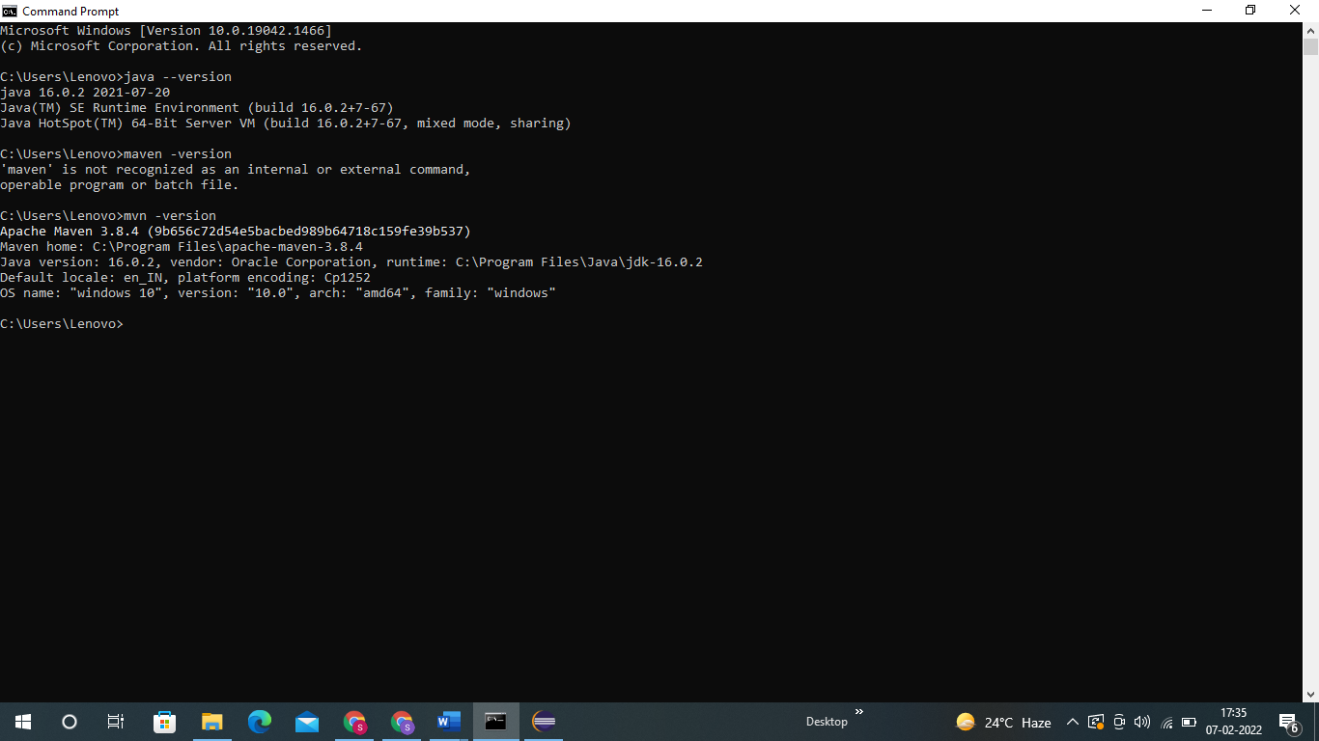

Step 2 :- Install Eclipse and then go to File and then click on new and then click on others.

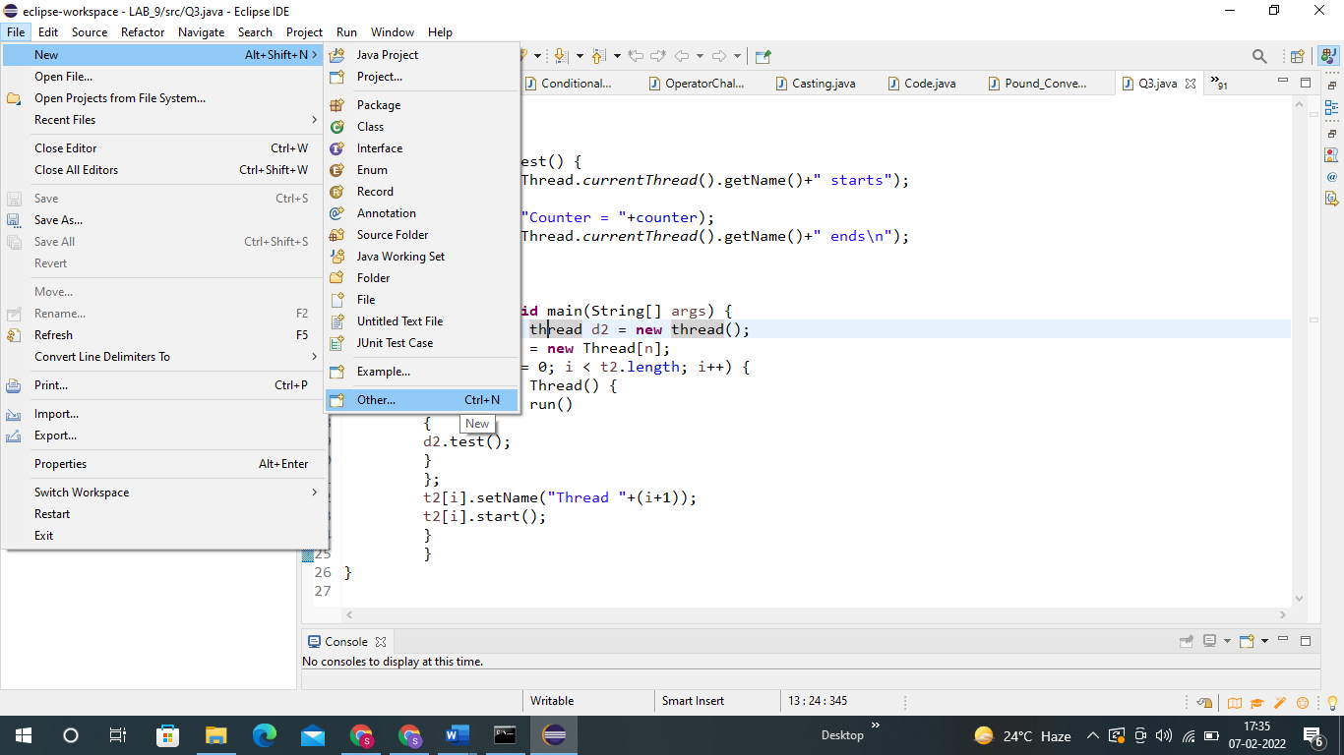

Step 3 :- Write maven on bar and then click on Maven project and then click on next.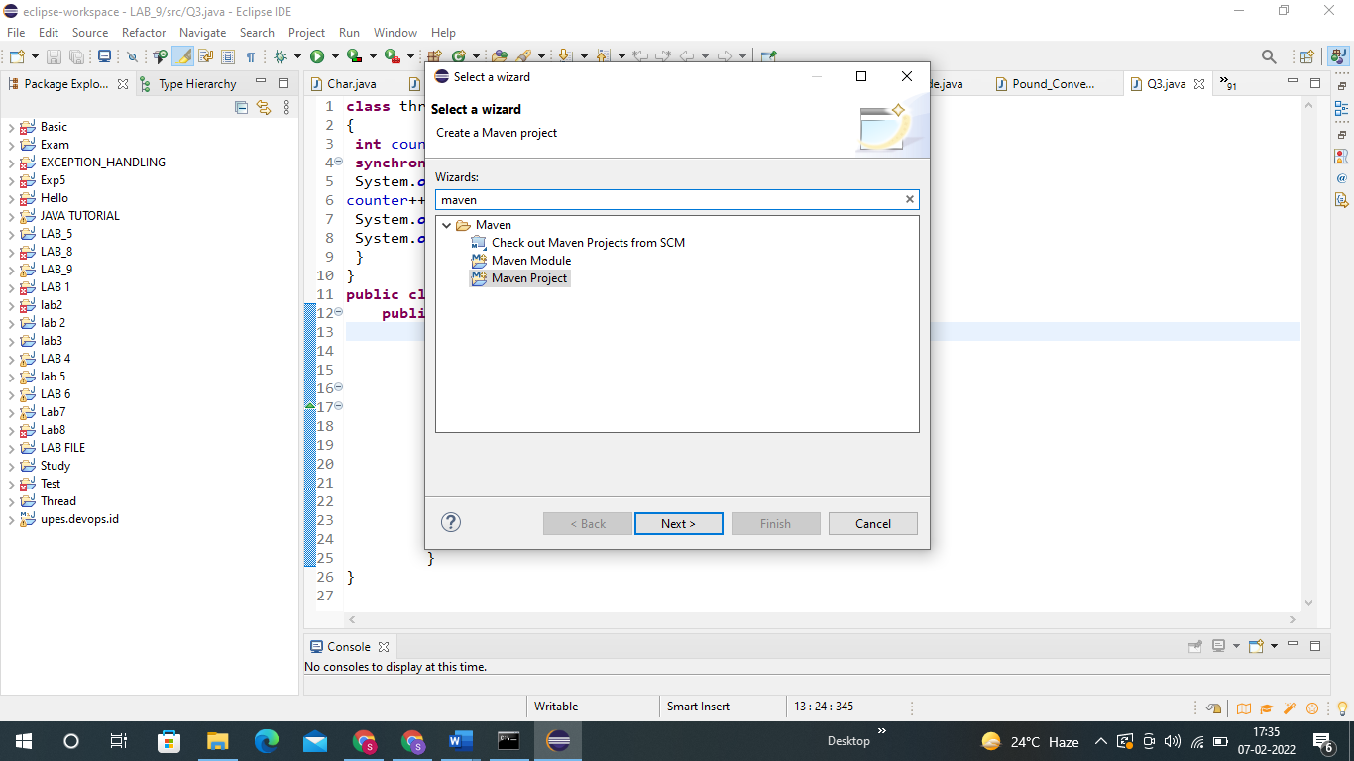

Step 4:- Check the two boxes and click on Next.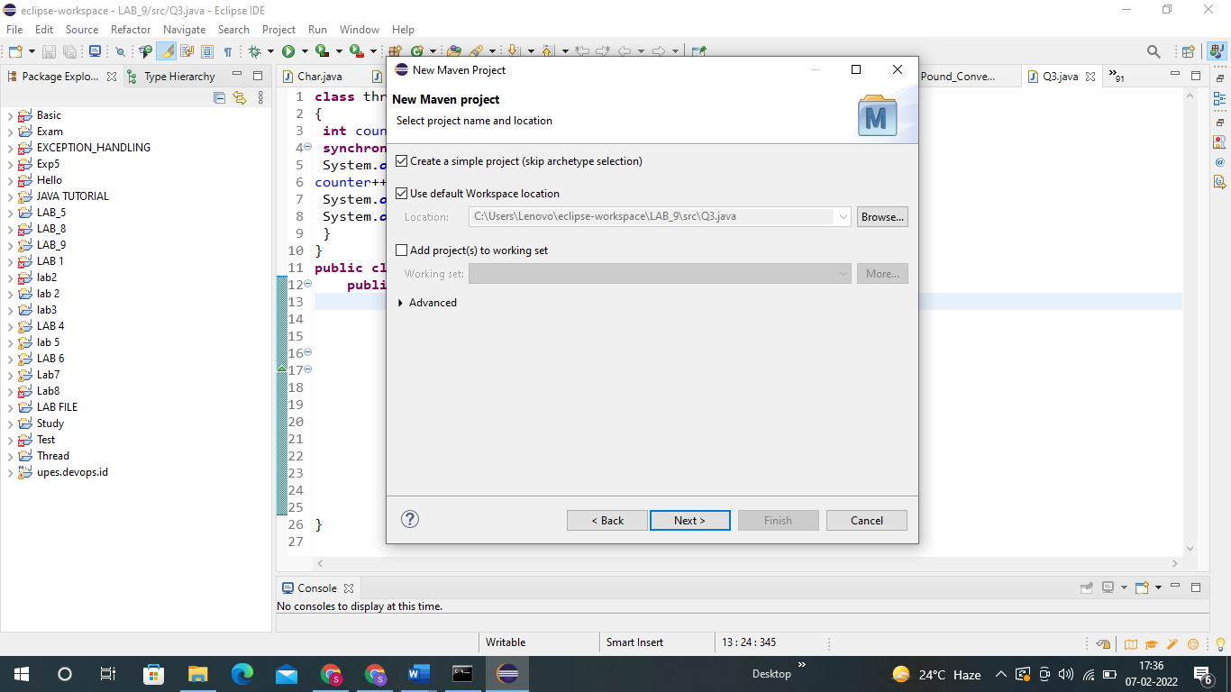

Step 5 :- Now do the nomenclature of Group id, Artifact id, and Name of the Project.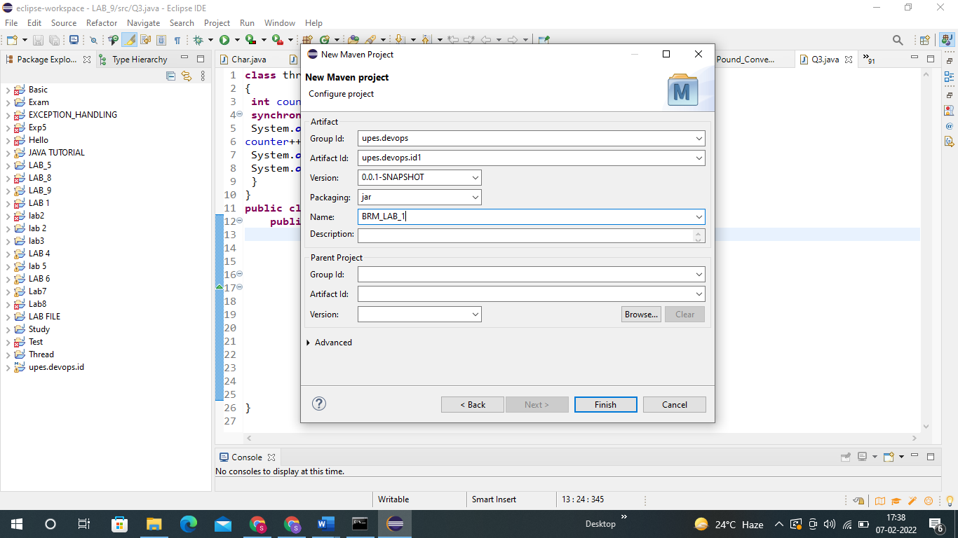

Step 6 :- Right click on project and create Java Class and then give name to it.

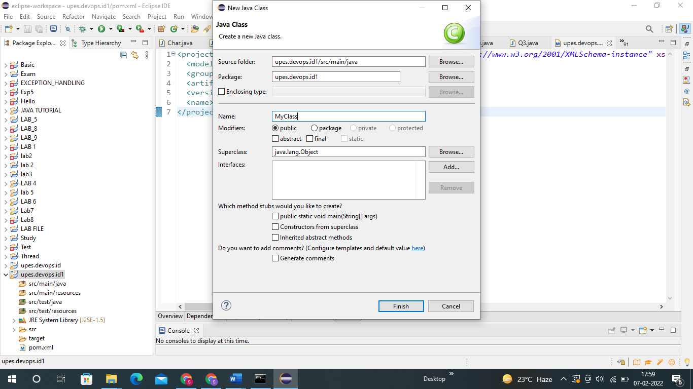

Step 7:- Write the Code and Compile it.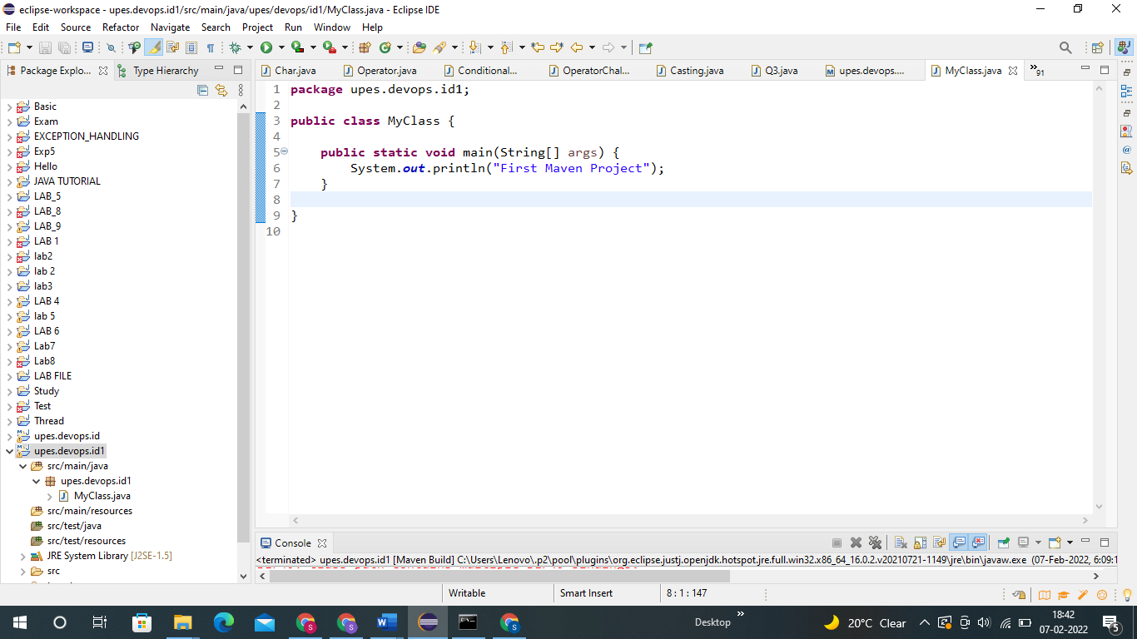

FINALLY WE HAVE CREATED OUR FIRST MAVEN PROJECT !!!!

1. **Run the following maven goals on this project**

* **Clean**
* **Compile**
* **Test-Compile**
* **Install**

1. **Clean**

**Step 1 :- Right Click on the project and then click on Run as and then on maven with three dots.**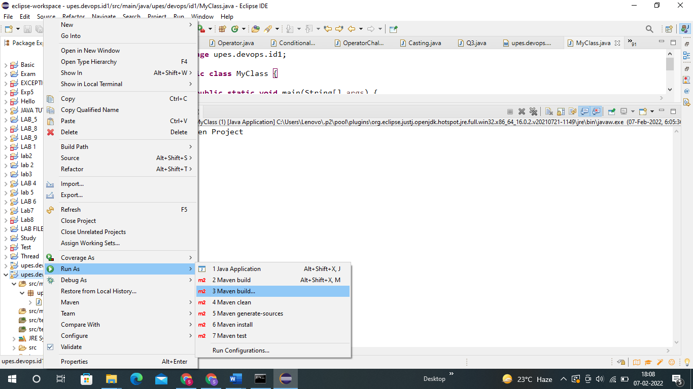

**Step 2:- Write clean as Goal and click on Run.**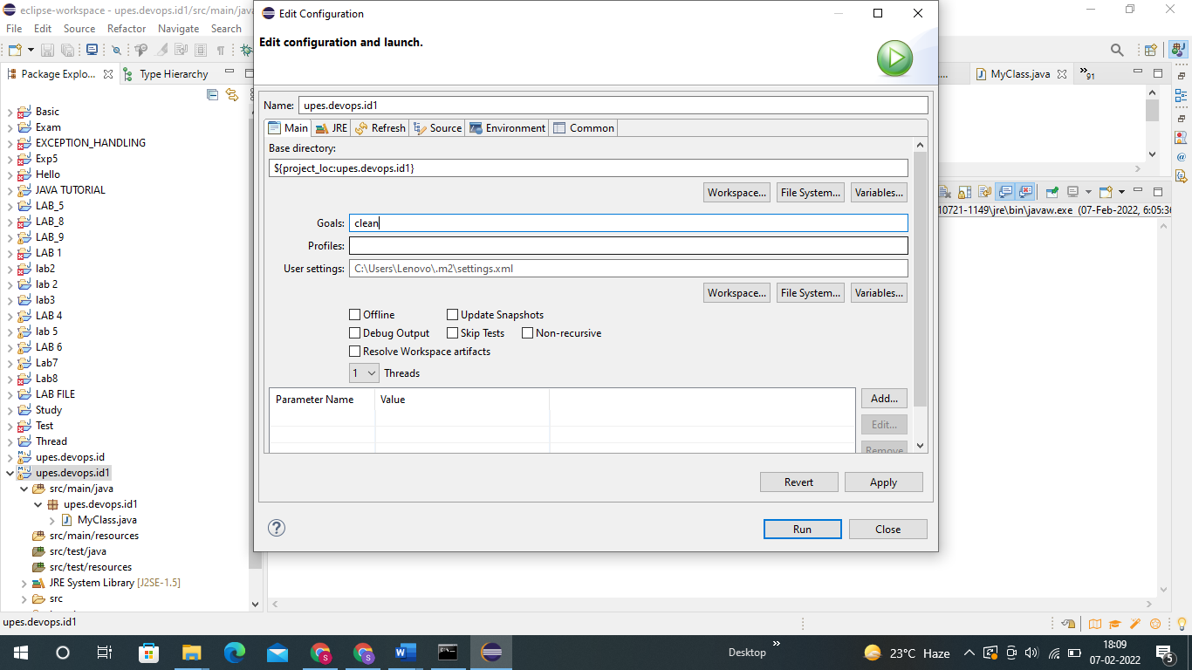

**Step 3 :- Finally Clean goal is runic and it is showing build syccess.** 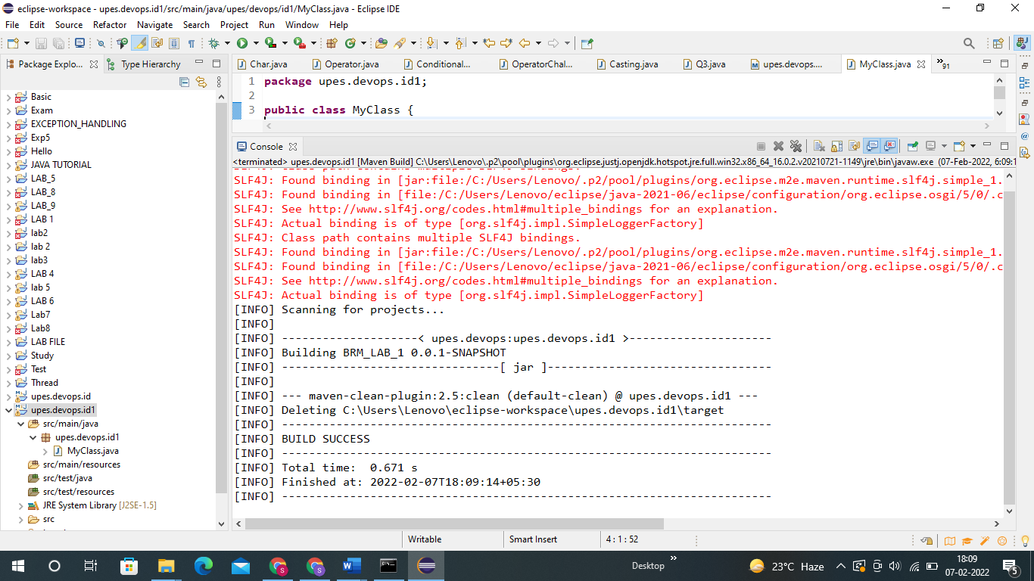

1. Compile

Similarly I set compile as goal and it executes BUILD SUCCESS

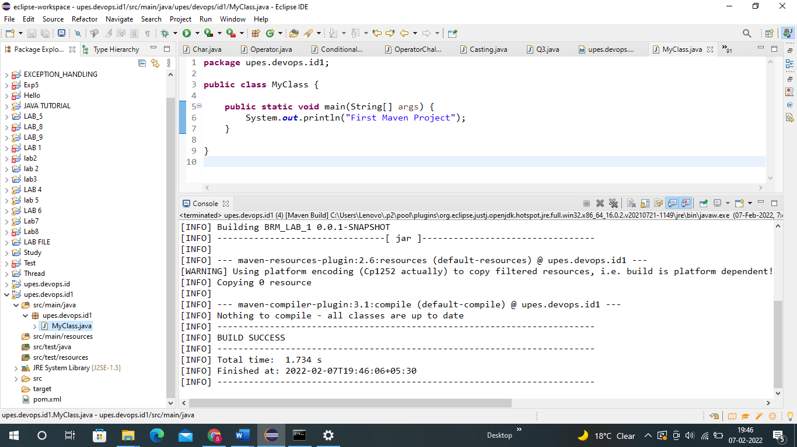

1. Test-Compile

Similarly I did this…

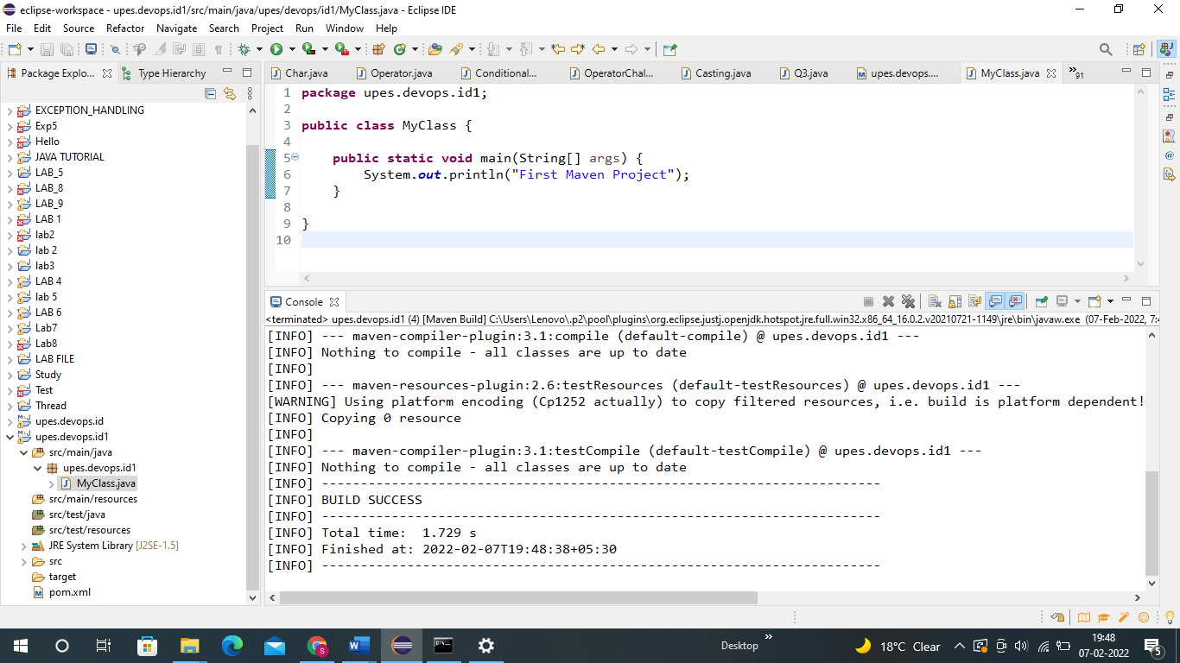

1. Install

Similarly I did Install

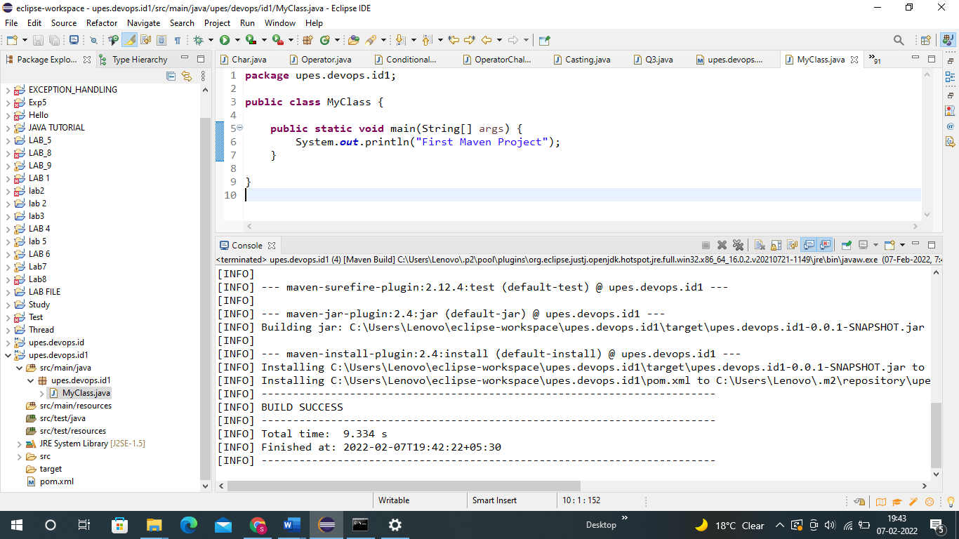

**THANK YOU**